26.44: a) 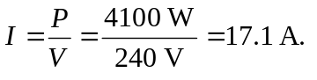 So we need at lest 14-gauge wire (good up to 18 A). 12 gauge is ok (good up to 25 A).
b) 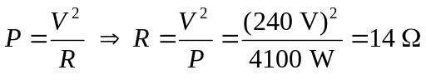
c)

